Stock price estimation of top 5 GPU companies

**21781A33C4(R PAVITHRA)**

**21781A33D0(S SONIYA)**

**21781A33D1(SANJANA K)**

**21781A33E9(V NAGASHANTHI) Team ID : 738312**

*Guided by*

***Prof.Ms Rasha***

*A Dissertation Submitted to SRI VENKATESWARA COLLEGE OF ENGINEERING AND TECHNOLOGY, An Autonomous Institution affiliated to ‘JNTU Ananthapur’ in Partial*

*Fulfilment of the Requirements for the Bachelor of Technology (Computer Engineering) with Specialization in Artificial Intelligence and Machine Learning.*

*MAY 2024*



*SRI VENKATESHWARA COLLEGE OF ENGINEERING AND TECHNOLOGY*

R.V.S Nagar Tirupati road, Andhra Pradesh-517127

#### Compliance certificate

**This is to certify that the research work embodied in this dissertation entitled “Stock Price Prediction Using Machine Learning” was carried out by 21781A33C4 (R Pavithra),**

**21781A33D0 (S Soniya), 21781A33D1 (Sanjana K), 21781A33E9 (V Nagashanthi) at Sri Venkateswara College of Engineering and Technology for partial fulfilment of Bachelor of Technology (Computer Engineering) with Specialization in Artificial Intelligence and Machine Learning degree to be awarded by JNTU Anantapur. We have complied to the comments given by the Dissertation phase – We as well as Mid Semester Dissertation Reviewer to our satisfaction.**

*Date : 11/05/2024 Place : Chittoor*

***(Prof .Ms Rasha)***

***Head ,(CSE(AI&ML))(M Dr Lavanya) Principal (Dr M Mohan Babu*** *)*



*SRI VENKATESHWARA COLLEGE OF ENGINEERING AND TECHNOLOGY*

R.V.S Nagar Tirupati road, Andhra Pradesh-517127

***Declaration of originality***

We hereby certify that We were the sole author of this dissertation and that neither any part of this dissertation nor the whole of the dissertation has been submitted for a degree to any other University or Institution.

We certify that, to the best of my knowledge, my dissertation does not infringe upon anyone’s copyright nor violate any proprietary rights and that any ideas, techniques, quotations or any other material from the work of other people

included in our dissertation, published or otherwise, are fully acknowledged in accordance with the standard referencing practices. Furthermore, to the extent that we have included copyrighted material that surpasses the bounds of fair dealing within the meaning of the Indian Copyright Act, We certify that we have obtained a written permission from the copyright owner(s) to include such material(s) in our dissertation and have included copies of such copyright clearances to our appendix.

We declare that this is a true copy of dissertation, including any final revisions, as approved by our dissertation review committee.

Date: 05/05/24 Place: Chittoor

21781A33C4 (R Pavithra) 21781A33D0 (S Soniya) 21781A33D1 (Sanjana K)

21781A33E9 (V Nagashanthi)

*SRI VENKATESHWARA COLLEGE OF ENGINEERING AND TECHNOLOGY*

R.V.S Nagar Tirupati Road, Andhra Pradesh-517127

*Abstract*

Researchers have been studying different methods to effectively predict the stock market price. Useful prediction systems allow traders to get better

insights about data such as: future trends.

Also, investors have a major benefit since the analysis give future conditions of the market.

One such method is to use machine learning algorithms for forecasting. This project’s objective is to improve the quality of output of stock market predicted by using stock value. A number of researchers have come up with various ways to solve this problem, mainly there are traditional methods so far, such as artificial neural network is a way to get hidden patterns and classify the data

which is used in predicting stock market. This project proposes a different method for prognosting stock market prices. It does not fit the data to a specific model; rather we are identifying the latent dynamics existing in the data using machine learning architectures. In this work we use Machine

learning architectures Long Short-Term Memory (LSTM), Convolutional Neural Network (CNN) and Hybrid approach of LSTM + CNN for the price forecasting of NSE listed companies and differentiating their performance. On a long term basis, sling window approach has been applied and the performance was

assessed by using root mean square error.

Acknowledgment

This thesis is based on research work conducted for “Stock Price Prediction Using Machine

Learning”. This work would not be possible without many people whose contributions can’t be ignored.

We would like to pay our special regards to Sri Venkateswara College of

Engineering and Technology for providing required resources for this work. We wish to express my sincere appreciation to our mentor Prof. Miss Rasha, whose assistance was a milestone in completion of this project and Prof. Sowmya

intelligently solved my queries. We owe our gratitude to the HOD OF

CSE(AI&ML) Dr. M Lavanya who helped in understanding different machine learning techniques. Without their support, a significant portion of project work was not possible in constrained time.

We must also appreciate our family and friends for helping us survive all the stress throughout the year. To our parents, for supporting me both on and off the water. We would like to thank you all mentioned and other people who have helped us directly or indirectly for pushing farther than we thought we could go.

**LIST OF FIGURES**

**TOPICS**

### stock price prediction

* 1. time series analysis
  2. fundamental analysis 1.3.technical analysis

1.4.applications 1.5.objectives

1.6.motivation

### share price estimation of top 5 GPU companies

* 1. project flow
  2. prior knowledge 2.3.project objectives 2.4.project structure

### data collection&preparation

* 1. collect the dataset
  2. importing the libraries 3.3.read the dataset
  3. data preparation
  4. checking for missing values 3.6.data manipulation
  5. resampling the data
  6. merging and splitting data into test and train variables

### explorotary data analysis

* 1. descriptive statistical 4.2.visual analysis

### model building

* 1. linear regression model 5.2.decision tree regressor 5.3.extra trees regressor
  2. random forest regressor
  3. model comparison and evaluating best model

### application building

* 1. building html pages 6.2.build python code 6.3.run the application

### Stock Price Prediction

Due to the high profit of the stock market, it is one of the most popular

investments. People investigated for methods and tools that would increase

their gains while minimizing the risk, as the level of trading and investing grew. Two stock exchanges namely- the National Stock Exchange (NSE) and the Bombay Stock Exchange (BSE), which are the most of the trading in Indian Stock Market takes place. Sensex and Nifty are the two prominent Indian

Market Indexes. Since the prices in the stock market are dynamic, the stock market prediction is complicated.

From gradually the very past years some forecasting models are developed for this kind of purpose and they had been applied to money market prediction. Generally, this classification is done by:

**Time series analysis Fundamental analysis Technical analysis 1.1.Time Series Analysis**

The definition of forecasting can be like this the valuation of some upcoming result or results by analysing the past data. It extents different areas like

industry and business, economics and finance, environmental science. Forecasting problems can be classified as follows:

Long term forecasting (estimation beyond 2 years)

Medium-term forecasting (estimation for 1 to 2 years)

Short term forecasting (estimation for weeks or months, days, minutes, few seconds) The analysis [1] of time consist of several forecasting problems. The designation of a time series is a linear classification of observations for a selected variable. The variable of the stock price in our case. Which can

weather multivariate or univariate? Only particular stock is included in the univariate data while more than one company for various instances of time is added in multivariate. For investigating trends, patterns and cycle or periods the analysis of time series advantages in the present data. In spending money wisely an early data of the bullish or bearish in the case of the stock market.

Also, for categorizing the best-performing companies the analysis of patterns plays its role for a specific period. This makes forecasting as well as time series analysis an important research area.

##### Fundamental analysis

Fundamental Analysts are concerned with the business that reasons the stock itself. They assess a company's historical performance as well as the reliability

of its accounts. Different performance shares are created that aid the fundamental forecaster with calculating the validity of a stock, such as the P/E ratio. Warren Buffett is probably the foremost renowned of all Fundamental Analysts.

What fundamental analysis within the stock market is making an attempt to reach, is organizing the true value of a stock, that then will be matched with

the worth it is being listed on stock markets and so finding out whether or not the stock on the market is undervalued or not. Find out the correct value will be completed by numerous strategies with primarily a similar principle. The principle is that an organization is price all of its future profits. Those future profits has to be discounted to their current value. This principle goes on the

theory that a business is all about profits and nothing else. Differing to

technical analysis, the fundamental analysis is assumed as further as a long approach.

Fundamental analysis is created on conviction that hominoid society desires capital to make progress and if the company works well, than it should be rewarded with an additional capital and outcome in a surge in stock price.

Fundamental analysis is usually used by the fund managers as it is the maximum sensible, objective and prepared from openly existing data like financial statement analysis.

One more meaning of fundamental analysis is on the far side bottom-up business analysis, it discusses the top-down analysis since initial analysing the world economy, followed by country analysis and also sector analysis, and last the company level analysis.

##### Technical analysis

Chartists or the technical analysts are not involved with any other of the fundamentals of the company. The long run price of a stock based generally exclusively on the trends of the past value (a form of time series analysis) that is set by them. The head and shoulders or cup and saucer are various

numerous patterns that are employed. Also the techniques, patterns are used just like the oscillators, exponential moving average (EMA), support and momentum and volume indicators. Candlestick patterns, believed to have been initial developed by Japanese rice merchants, are nowadays widely used by

technical analysts. For the short-term approaches, the technical analysis is used

compare to long-run ones. So, in commodities and forex markets it is more predominant wherever traders target short-term price movements. There are basic rules are used in this analysis, first all significant about a company is already priced into the stock, another being that the value changes in trends

and finally that history (of prices) tends to repeat itself that is especially due to the market science.

* 1. **Applications** Business Companies

Insurance company Government Agency

This application is helpful for stock investors, sellers, buyers, brokers.

##### Objectives

A stock market prediction is described as an action of attempting to classify the future value of the company stock or other financial investment traded on the stock exchange. The forthcoming price of a stock of the successful estimation is called the Yield significant profit. This helps you to invest wisely for making good profits.

##### Motivation

The future price of a stock is the main motivation behind the stock price

prediction. In various cases like business and industry, environmental science, finance and economics motivation can be useful. The future value of the company’s stock can be determining

# Share Price Estimation Of TOP 5 GPU Companies

The objective of this project is to estimate the share prices of the top 5 GPU companies in the market using historical data and current market trends. The aim is to develop a predictive model that can forecast the future prices of these companies based on their historical performance and other relevant factors. The model should take into consideration various economic indicators, industry trends, company financials, and other relevant data to make accurate predictions. The analysis should be performed using statistical and machine learning/ Deep learning techniques and the results should be presented in a clear and concise manner. The final output of the project will be a report outlining the predicted share prices of the top 5 GPU companies in the market, along with an analysis of the factors that have contributed to their performance.

Technical Architecture:

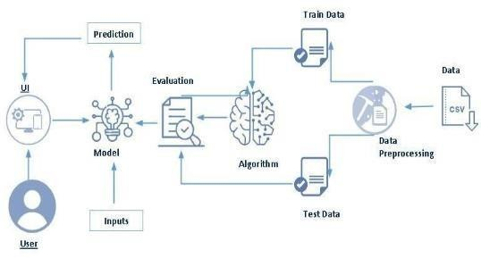

## Project Flow

User interacts with the UI to enter the input.

Entered input is analysed by the model which is integrated.

Once model analyses the input the prediction is showcased on the UI To accomplish this, we have to complete all the activities listed below,

* + - Data Collection & Preparation o Collect the dataset

o Data Preparation

* + - Exploratory Data Analysis
      * Descriptive statistical o Visual Analysis
    - Model Building o Training the model in multiple algorithms o Testing the model
    - Performance Testing & Hyperparameter Tuning o

Testing model with multiple evaluation

metrics

* + - * Comparing model accuracy before & after applying hyperparameter tuning
    - Model Deployment o Save the best model o

Integrate with Web Framework

* + - Project Demonstration & Documentation o Record explanation Video for project end to end solution o

Project Documentation-Step by step project development procedure

## Prior Knowledge

To complete this project, you must require the following software, concepts, and packages

* + - Anaconda Navigator:
    - Refer to the link below to download anaconda navigator Link: <https://www.youtube.com/watch?v=5mDYijMfSzs>Python packages:
    - open anaconda prompt as administrator
    - Type “pip install prophet” (make sure you are working on Python 64 bit)
    - Type “pip install flask”.
    - Deep Learning Concepts
    - CNN[: https://towardsdatascience.com/basics-of-the-classic-cnn-a3dce1225add](https://towardsdatascience.com/basics-of-the-classic-cnn-a3dce1225add)
    - ARIMA[: https://www.investopedia.com/terms/a/autoregressive-integrated-](https://www.investopedia.com/terms/a/autoregressive-integrated-moving-average-arima.asp#%3A~%3Atext%3DAn%20autoregressive%20integrated%20moving%20average%2C%20or%20ARIMA%2C%20is%20a%20statistical%2Cvalues%20based%20on%20past%20values) [movingaveragearima.asp#:~:text=An%20autoregressive%20integrated%20moving%20a](https://www.investopedia.com/terms/a/autoregressive-integrated-moving-average-arima.asp#%3A~%3Atext%3DAn%20autoregressive%20integrated%20moving%20average%2C%20or%20ARIMA%2C%20is%20a%20statistical%2Cvalues%20based%20on%20past%20values) [verage%2](https://www.investopedia.com/terms/a/autoregressive-integrated-moving-average-arima.asp#%3A~%3Atext%3DAn%20autoregressive%20integrated%20moving%20average%2C%20or%20ARIMA%2C%20is%20a%20statistical%2Cvalues%20based%20on%20past%20values) [C%20or%20ARIMA%2C%20is%20a%20statistical,values%20based%20on%20pa](https://www.investopedia.com/terms/a/autoregressive-integrated-moving-average-arima.asp#%3A~%3Atext%3DAn%20autoregressive%20integrated%20moving%20average%2C%20or%20ARIMA%2C%20is%20a%20statistical%2Cvalues%20based%20on%20past%20values) [st%20values.](https://www.investopedia.com/terms/a/autoregressive-integrated-moving-average-arima.asp#%3A~%3Atext%3DAn%20autoregressive%20integrated%20moving%20average%2C%20or%20ARIMA%2C%20is%20a%20statistical%2Cvalues%20based%20on%20past%20values)
    - LSTM: [https://www.analyticsvidhya.com/blog/2021/03/introduction-to-long-shortterm-](https://www.analyticsvidhya.com/blog/2021/03/introduction-to-long-short-term-memory-lstm/) [memory-lstm/](https://www.analyticsvidhya.com/blog/2021/03/introduction-to-long-short-term-memory-lstm/)
    - SARIMA[: https://machinelearningmastery.com/sarima-for-time-series-forecastingin-](https://machinelearningmastery.com/sarima-for-time-series-forecasting-in-python/) [python/](https://machinelearningmastery.com/sarima-for-time-series-forecasting-in-python/)
    - Facebook Prophet[: https://www.geeksforgeeks.org/time-series-analysis-usingfacebook-](https://www.geeksforgeeks.org/time-series-analysis-using-facebook-prophet/) [prophet/](https://www.geeksforgeeks.org/time-series-analysis-using-facebook-prophet/)

Flask Basics[: https://www.youtube.com/watch?v=lj4I_CvBnt0](https://www.youtube.com/watch?v=lj4I_CvBnt0)

## Project Objectives

By the end of this project you will:

* + - know fundamental concepts and techniques of Convolutional Neural Network.
    - gain a broad understanding of image data.
    - Knowhow to pre-process/clean the data using different data preprocessing techniques.
    - know how to build a web application using Flask framework.

# Project Structure

Create the Project folder which contains files as shown below

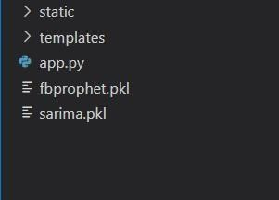

* + - We are building a Flask application with HTML pages stored in the templates folder and a Python script app.py for scripting.
    - The static folder and assets folder contains the CSS and JavaScript files along with images.
    - fbprophet.pkl, lstm.h5 and sarima.pkl are our saved models.

Further we will use these models for flask integration.

## Data Collection & Preparation

DL depends heavily on data. It is the most crucial aspect that makes algorithm training possible. So, this section allows you to download the required dataset.

## Collect The Dataset

There are many popular open sources for collecting the data kaggle.com, UCI repository, etc.

In this project, we have used .csv data. This data is downloaded from kaggle.com. Please refer to the link given below to download the dataset.

As the dataset is downloaded. Let us read and understand the data properly with the help of some visualization techniques and some analyzing techniques.

Note: There are a number of techniques for understanding the data. But here we have used some of it. In an additional way, you can use multiple techniques.

**DATASET**

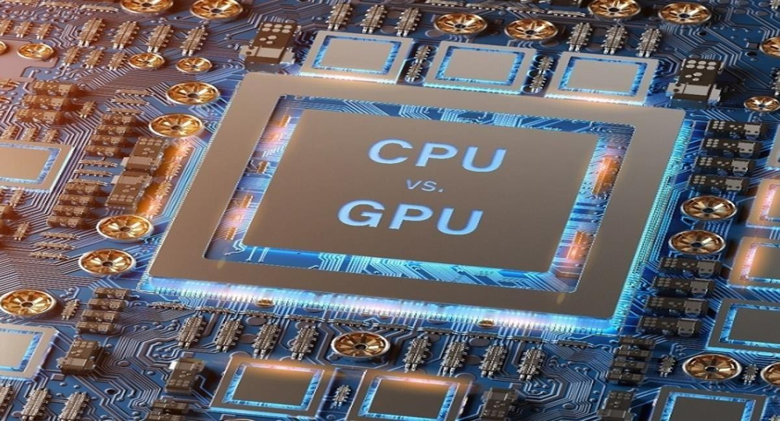

💻👩🏻💻 ***NVIDIA AMD Intel MSI share prices | Kaggle..***

Share prices of 5 biggest companies who make GPU.. <https://www.kaggle.com/datasets/kapturovalexander/nvidia-amd-intel-asus-msi-share-prices>

## Importing The Libraries

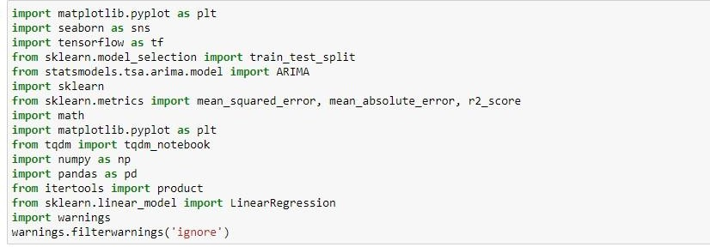Import the necessary libraries as shown in the image.

# Read The Dataset

Our dataset format might be in .csv, excel files, .txt, . json , etc. We can read the dataset with the help of pandas.

In pandas, we have a function called read_csv() to read the dataset. As a parameter, we have to give the directory of the CSV file.

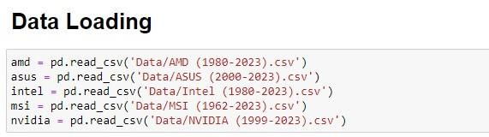

We can print the first 5 rows of the datasets using the .head() method as shown in the below screenshots.

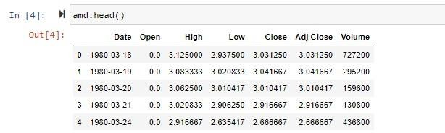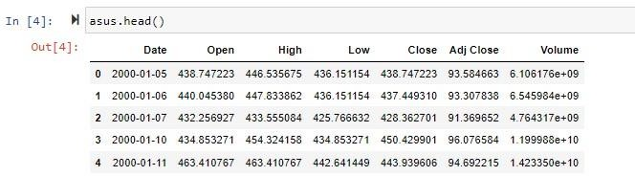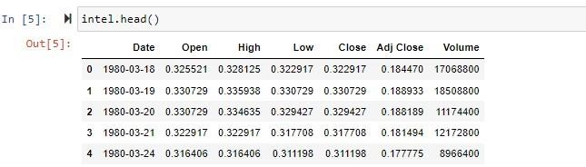

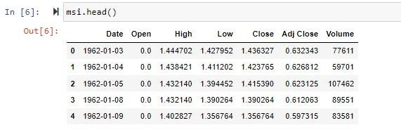

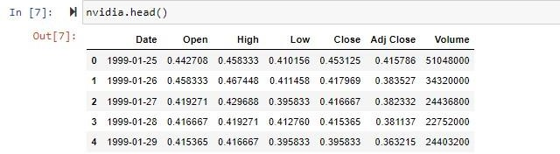

## Data Preparation

*As we have understood how the data is, let's pre-process the collected data.*

The download data set is not suitable for training the machine learning model as it might have so much randomness so we need to clean the dataset properly in order to fetch good results. This activity includes the following steps.

* + - Checking for missing values
    - Data manipulation
    - Resampling the data
    - Merging and splitting data into test and train variables

Note: These are the general steps of pre-processing the data before using it for training models. Depending on the condition of your dataset, you may or may not have to go through all these steps.

## Checking For Missing Values

For checking the null values, df.isnull() function is used. To sum those null values we use .sum() function. From the below image we found that there are no null values present in our dataset. So we can skip handling the missing values step.

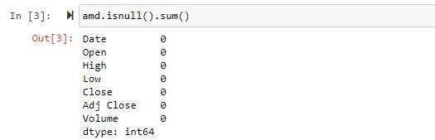

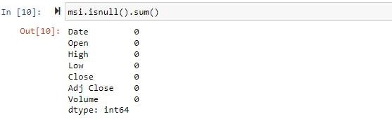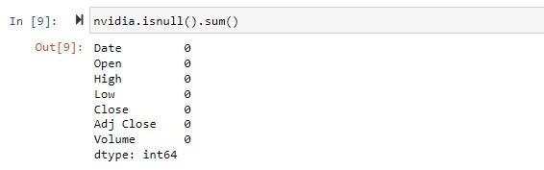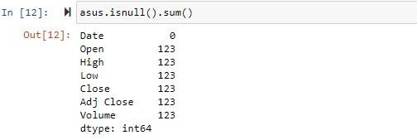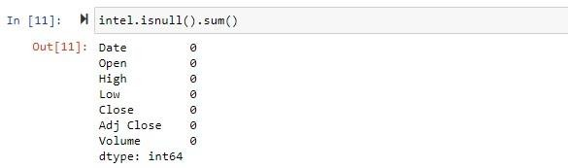

## Data Manipulation

Since we found null values in the dataset related to ASUS company we are going to drop the null values but we can also fill those null values using mean/median/mode of the respective volumns.



To convert the date strings to time stamps we are going to perform below steps. First let’s check the type of data of the column “Year” using the type() function.

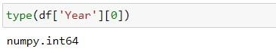

We will convert the data of “Year” column using the pandas “to_datetime” function. We can change the ‘Date’ columns of all the datasets using a for loop to reduce Lines of code..

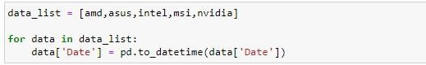

## Resampling The Data

Now we are going to add new columns to all the loaded datasets so that when we merge our data it will be easier to find which rows of data belong to which company and also so that our model will be able to differentiate the rows of data based on the value of the new column named “Company”. The new column “Company” will be a categorical value ranging from 0 to 4 where each number denotes a company as shown below. We are going to process the datasets as mentioned above using a for loop.

We will also three new columns of data namely “Year”, “Day” and “Month” which are derived from the “Date” column. We will use these three columns for training not the “Date” columns but we use the “Date” column for analysis in later stages.

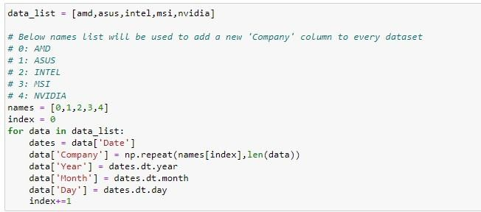

## Merging And Splitting Data Into Test And Train Variables

Now we are going to merge our datasets, simultaneously we are also going to split the data to test and train variables using the below piece of code with a train to test ratio of 80 to 20.

First we are going to take 2 lists of train and test in which we are going to append train and test splits of every dataset into these 2 lists. In the output each line represents the data of companies in order as stored in the data_list in below code.

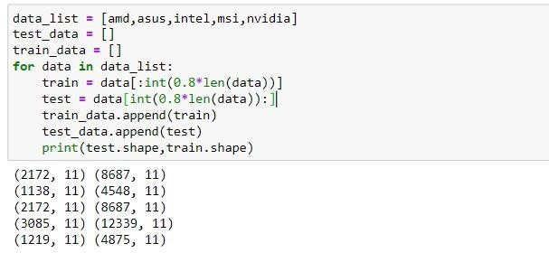

Next we are going to merge the data of each variable of train_data and test_data using the pandas.concat() function as shown below.

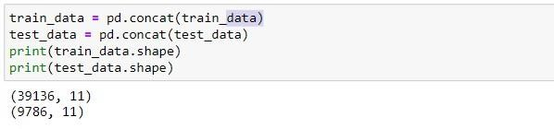

Finally we are going to split the train_data and test_data variables into x_train, y_train, x_test and y_test using the below piece of code.

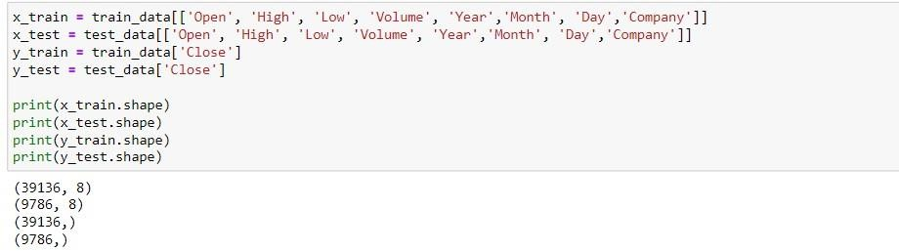

## Exploratory Data Analysis

* 1. *Descriptive Statistical*

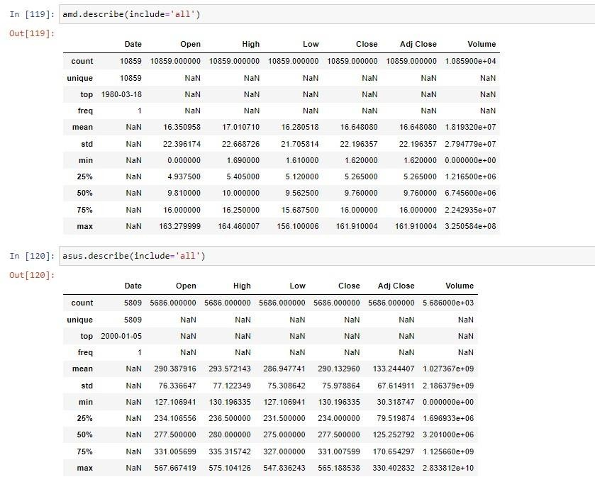Descriptive analysis is to study the basic features of data with the statistical process. Here pandas has a worthy function called describe. With this describe function we can understand the unique, top and frequent values of categorical features. And we can find mean, std, min, max and percentile values of continuous features.

## Visual Analysis

Visual analysis is the process of using visual representations, such as charts, plots, and graphs, to explore and understand data. It is a way to quickly identify patterns, trends, and outliers in the data, which can help to gain insights and make informed decisions.

###### Univariate analysis

In simple words, univariate analysis is understanding the data with single feature. Here we don’t have much need to perform univariate analysis to understand the data as most of the columns provided are continuous.

###### Bivariate analysis

To find the relation between two features we use bivariate analysis.

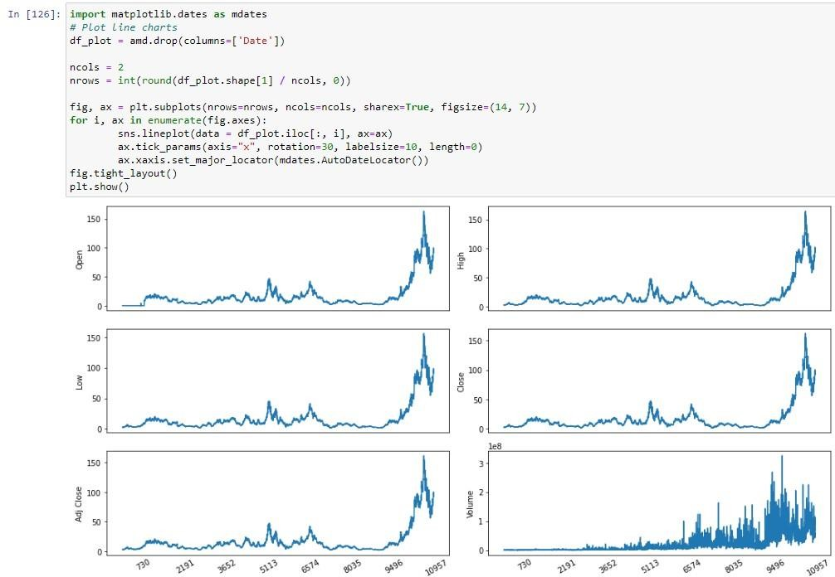

In the line plots visualised below following observations can be observed:

* There is sudden increase in the prices of stocks of AMD in the recent years and the price of the stock didn’t retain for a long period but it soon fell to a lower price.
* The volume of the stocks being traded have increased tremendously in the recent years.

Similar to this, analysis on other companies can be done.

## Model Building

Now our data is cleaned and it’s time to build the model. We can train our data on different algorithms. For this project we are applying seven classification algorithms. The best model is saved based on its performance.

# Linear Regression Model

First we are going to initialise the LinearRegression() model and training data is passed to the model with.fit() function. Test data is forecasted/predicted with predict() function and saved in a new variable. For evaluating the model, train score, test score, r2_score and MAE scores are used.

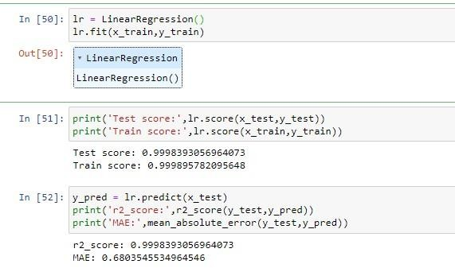

## Decision Tree Regressor

First we are going to initialise the DecisionTreeRegressor () model and training data is passed to the model with.fit() function. Test data is forecasted/predicted with predict() function and saved in a new variable. For evaluating the model, t

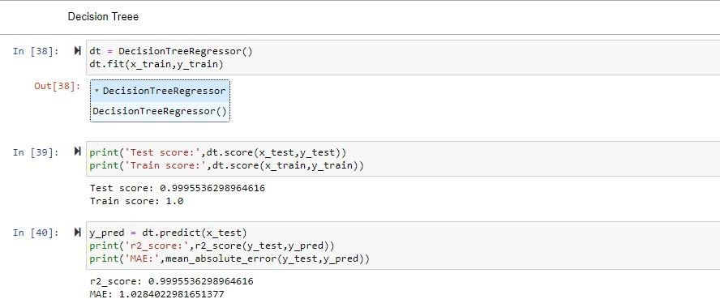

## Extra Trees Regressor

First we are going to initialise the ExtraTreeRegressor () model and training data is passed to the model with.fit() function. Test data is forecasted/predicted with predict() function and saved in a new variable. For evaluating the model, train score, test score, r2_score and MAE scores are

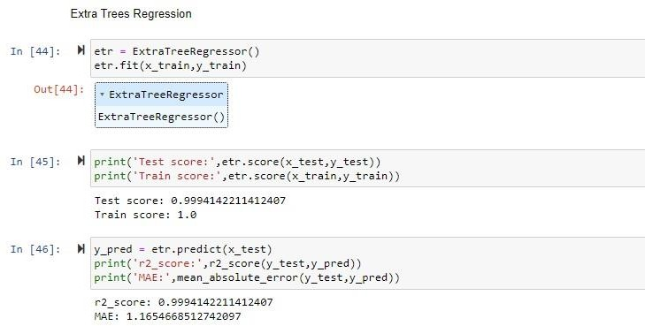used.

## Random Forest Regressor

First we are going to initialise the RandomForestRegressor () model and training data is passed to the model with.fit() function. Test data is forecasted/predicted with predict() function and saved in a new variable. For evaluating the model, train score, test score, r2_score and MAE scores are used.

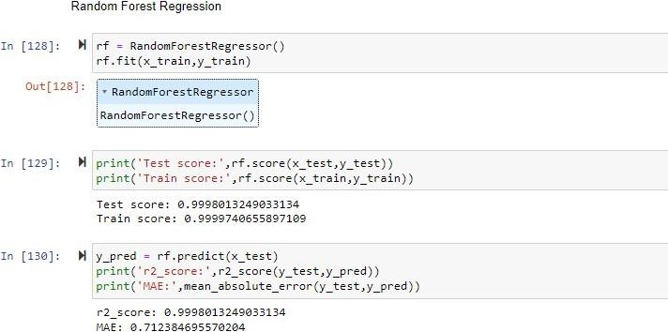

## Model Comparison And Evaluating Best Model

From the observed r2 scores and Mena absolute errors we can clearly see that the linear regression model has least Mean absolute error among others. So we are going to select Linear Regression model for final Flask application deployment.

To plot the predictions over the original values of all the companies we can use the following code.

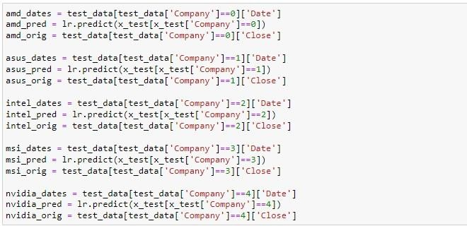First, we are going to store the dates, original closing prices of stocks and predicted closing prices of stocks as shown below. We are going to access company specific rows of test_data and x_test variables using the “Company” column.

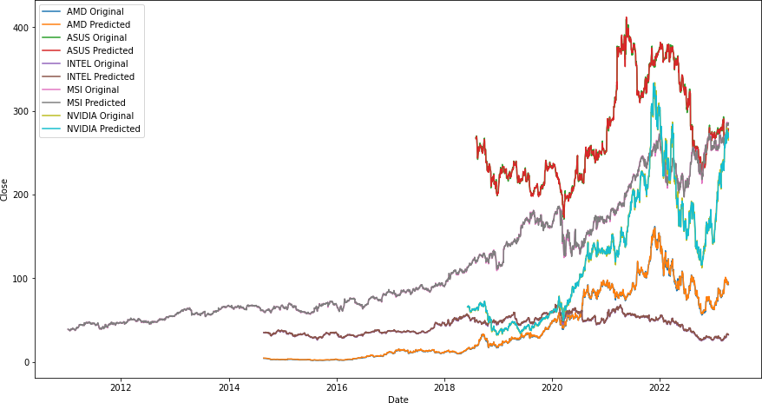Now using these columns we are going to plot the data as shown below.

As we can see the lines plotted by the predicted and original data are almost perfectly overlapping.

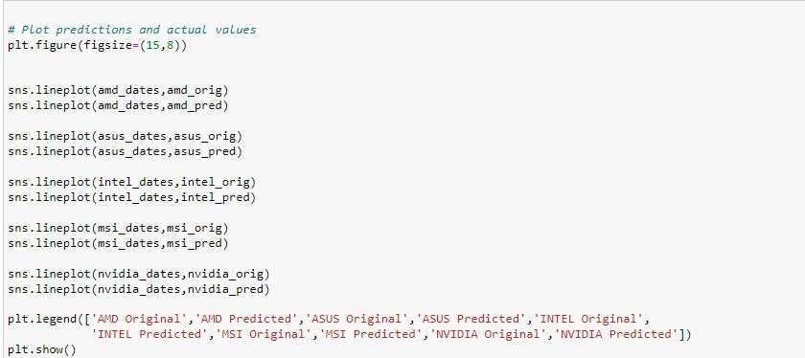

## Application Building

In this section, we will be building a web application that is integrated to the model we built. A UI is provided for the uses where he has to enter the values for predictions. The enter values are given to the saved model and prediction is showcased on the UI. This section has the following tasks Building HTML Pages

 Building server-side script

## Building Html Pages

For this project create two HTML files namely

* + - index.html
    - inner-page.html
    - portfolio-details.html and save them in the templates folder.

It is not necessary to follow the exact format as above so feel free to use whatever templates or format you like. Be creative!

## Build Python Code

Import the libraries



Load the saved model. Importing the flask module in the project is mandatory. An object of Flask class is our WSGI application. Flask constructor takes the name of the current module ( name ) as argument.



Render HTML page:

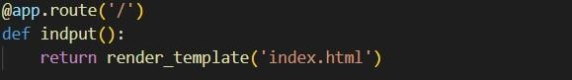

Here we will be using a declared constructor to route to the HTML page which we have created earlier.

In the above example, ‘/’ URL is bound with the index.html function. Hence, when the home page of the web server is opened in the browser, the html page will be rendered.

Whenever you enter the values from the html page the values can be retrieved using POST Method. Retrieves the value from UI:

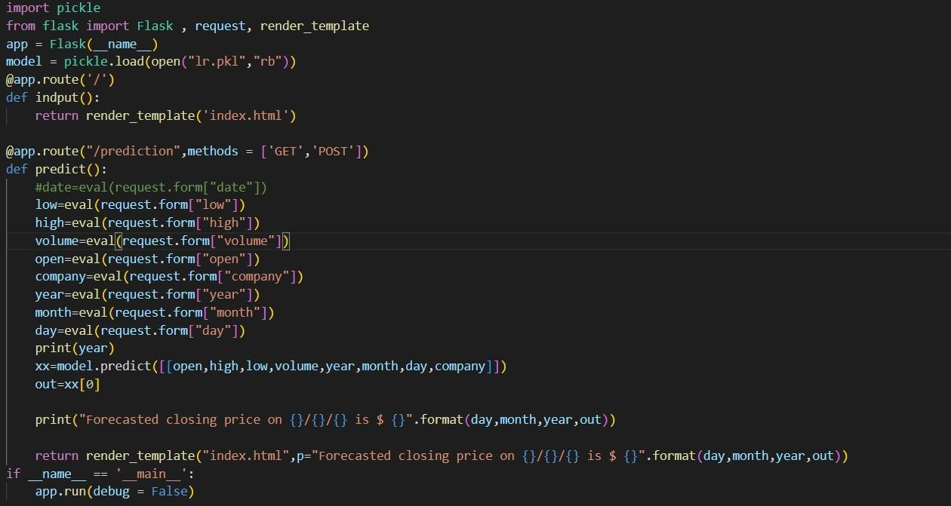

Here we are routing our app to predict() function. This function retrieves all the values from the HTML page using Post request. That is stored in an array. This array is passed to the model.predict() function. This function returns the prediction. And this prediction value will be rendered to the text that we have mentioned in the submit.html page earlier.

## Run The Application

* + - Open anaconda prompt from the start menu  Navigate to the folder where your python script is.
    - Now type “python app.py” command
    - Navigate to the localhost where you can view your web page.
    - Click on the predict button from the top left corner, enter the inputs, click on the submit button, and see the result/prediction on the web.

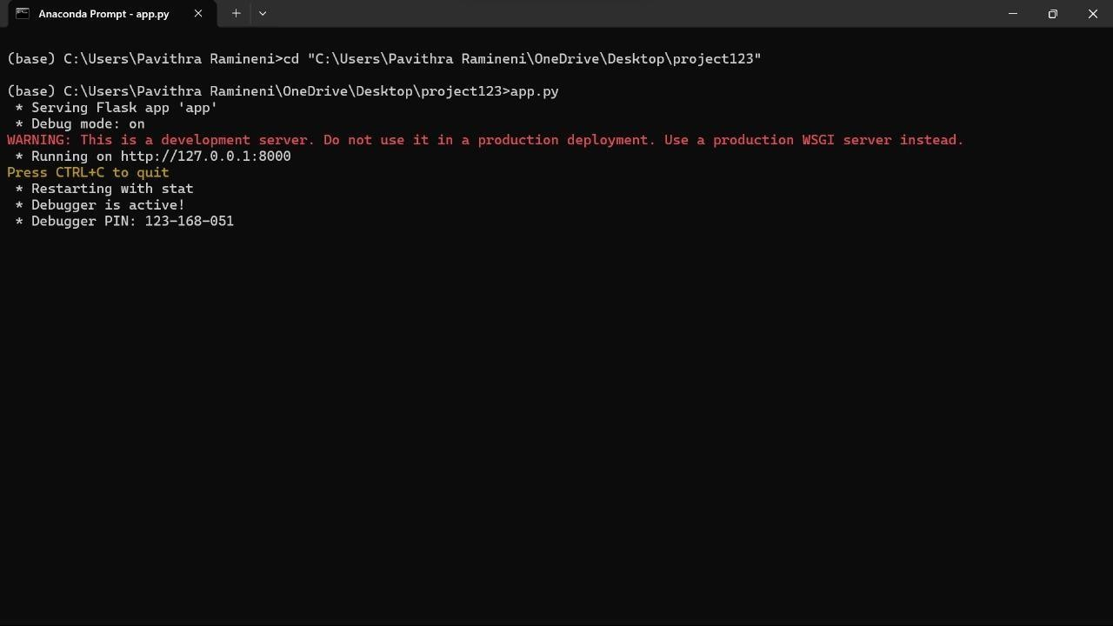

Now, Go to the web browser and write the localhost URL ( http://127.0.0.1:5000 ) to get the below result

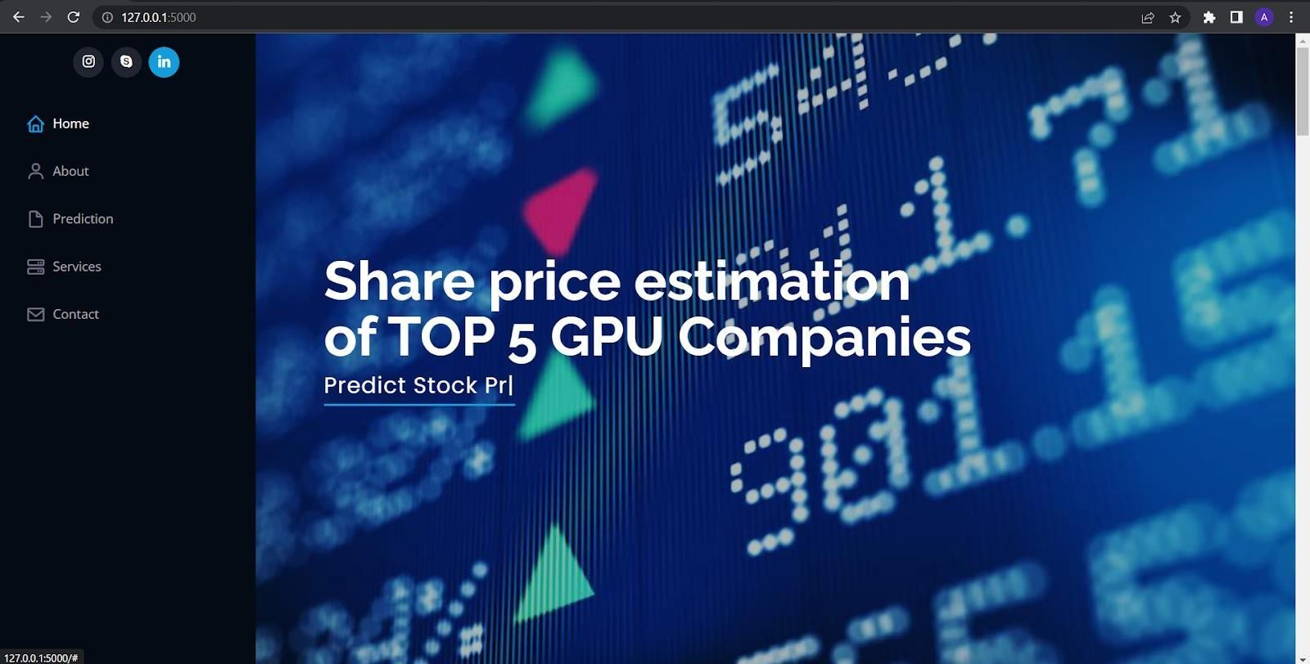

Upon entering the data in input fields and clicking on submit and predict we’ll get the prediction as shown below.

Application building:

